Do what you can, don’t worry if you cannot complete everything.

You can find all the resources on the school website under our class page “5th Ms. Cleary”.
There is a word document on our webpage with images from your History and Science books.

Monday
English | Reading:  - My Read at home: pg. 104 + answer questions orally  - Up and Running: wordlist “The Hat and the Superglue” (on class page)  - Up and Running: pg. 194, 195, 196 of the text “The Hat and the Superglue”.  Writing:  - Wordlist: 3 x WL sentences  - My Spelling Workbook: Unit 16, LSCWC x4 spellings (2 list, 2 revision)  - My Spelling Workbook: Exercise 6
Mindfulness | - Read Page 13 of your Weaving Wellbeing Work Pack and fill in number 7.  - Don’t forget to continue with the acts of kindness activity on page 11 this week until you have 5 days filled.  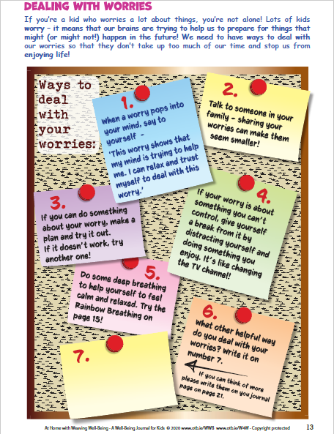  If you can, listen to calming music while you do these activities every day to help you relax.
P.E | Complete the “Blast Off” full body work out on go noodle  https://www.youtube.com/watch?v=K4DnPhR9_mo&t=42s  Get as many people in the family to join in as you can!
Maths | Planet Maths: Pg. 138 – Topic: The Circle  NB: You will need a compass and a ruler to complete the maths work this week.  - Play this warm up game to revise your knowledge of 2D shapes on folens.ie :  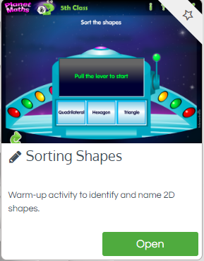  - Exercise B (1): Write 5 sentences about the properties of a circle using the help words to guide you.  - Write the answers to ex. B (2) True/False in your copy. (Go back to the chapter on 2D shapes to help you if you forget the meaning any of the terms e.g. polygons).  - Test your knowledge of the properties of a circle by playing the game on folens.ie  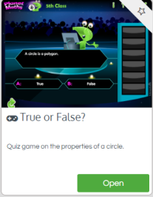  - Tables Champion: Monday  - Mental Maths: Monday
Religion | - Read: Theme 9 Lesson 2 pg. 102  - Answer the questions orally.  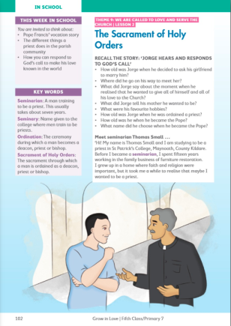  Visit: Grow in Love online with the help of a parent (only of you can) and under 5th class, Theme 9 Lesson 2, you will have access to the songs for the lesson this week, along with other resources.
Gaeilge | Téama: Caitheamh Aimsire (Hobbies)  Use folens online.ie to access the online resources.  - Féach ar an foclóir nua arís. (Look at the new vocabularly again, there is a word document on the class page).  - Éist leis an cómhra “Páirc an Chrócaigh” (Listen to the conversation about Croke Park being read aloud).  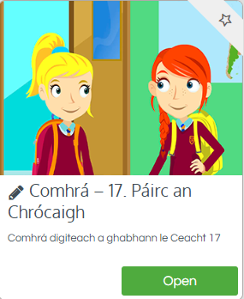  - Anois léigh an cómhrá ar lch 126 (Now read the conversation out loud.)  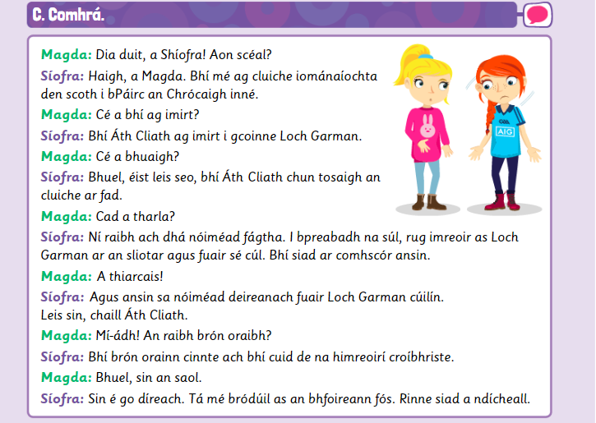
History | Topic: Martin Luther King (Another very interesting topic!)  What do you already know about Martin Luther King? What would you like to find out? (Orally)  - Watch this short animated video as an introduction to learning about Martin Luther King: https://www.youtube.com/watch?v=k6Au81aHuSg  - Read about Martin Luther King on pages 92, 93 + 94 of your History book.  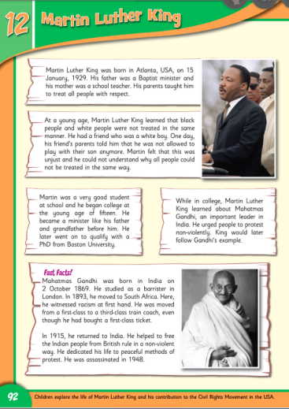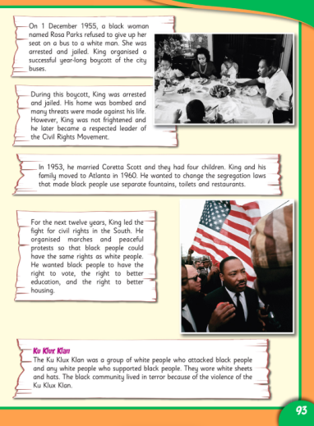

Tuesday
English | Reading:  - My Read at home: pg. 105 + answer questions orally  - Up and Running: wordlist  - Up and Running: pg. 197, 198, 199, 200 of the story “The Hat and the Superglue”.  - DEAR: 10 mins  Writing:  - My Spelling Workbook: Unit 16, LSCWC x4 spellings (revision words)  - My Spelling Workbook: Exercise 7  - Grammar: Up & Running, pg. 202 Ex. E Antonyms in copy/word doc
P.E  Mindfulness | Do the “Rock Out” exercise on Go Noodle  https://www.youtube.com/watch?v=3KReaoKLA-4  Read page 14 of your Well-being journal and complete the activity.  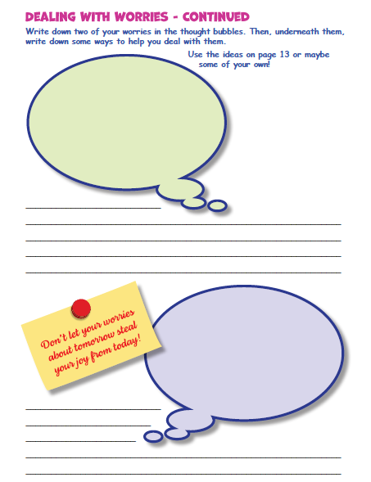
Maths | Planet Maths: Pg. 139  Topic: Data 2  *Today you will be learning to draw a circle using a compass for the first time. It is very important that you watch this video carefully, at least once or twice, before trying to draw your own. It explains it very well and clearly.  Access the video here: https://www.youtube.com/watch?v=02XRad7s1Io  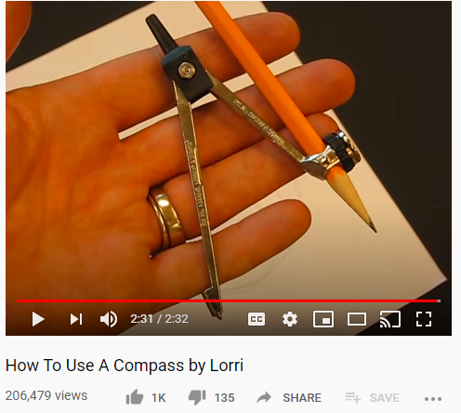  (You can also access this video on our webpage)  - Now watch this second video on folens.ie  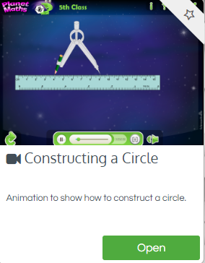  - Read the blue box on pg. 139 explaining the steps you need to take to draw a circle.  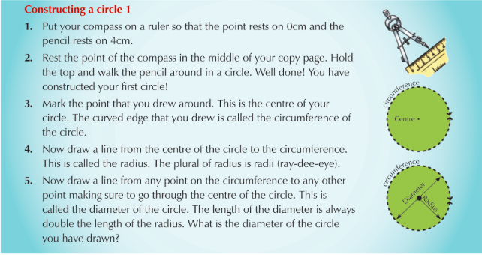  Following the steps carefully, try and draw your own circle. This can be tricky at the start when you’re not used to it so it may take a few times. Be patient with it – practice makes perfect!  - Complete exercise A (1-3) in your copy or on squared paper if you have it.  *(Remember, the radius of the circle in the question is how far you have to stretch out your pencil. For example, question A 1 (a) asks you to draw a circle with a radius of 5cm. That means you put the sharp point of your compass on 0cm on your ruler, and then you stretch out your pencil so that it rests exactly on 5cm. Be careful, sometimes it gives you the diameter of the circle instead, so to get the radius you just half the diameter.  - Tables Champion: Tuesday  - Mental Maths: Tuesday
Religion | - Read about the twelve apostles and Fr. Gerry Moore on page 103 + 104  - Complete the Revision Activity on pg. 104 in your copy.  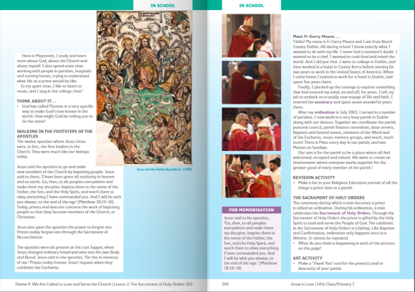
Gaeilge | - Freagair ceacht D lch. 126 (Answer D in your copy). Look at the scores of both teams and then use the new phrases in the purple boxes on the top of page 124 to help you fill in the blanks.  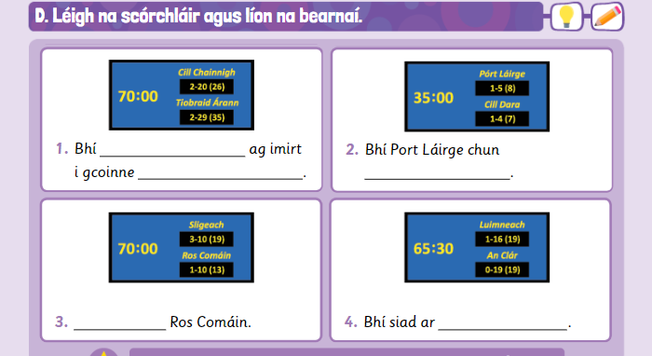  2. Éist le Amhrán na bhFiann (Listen to Amhrán na bhFiann (Our national anthem!)  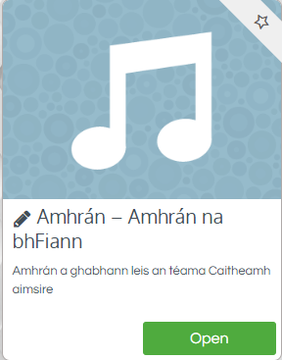  3. Anois léigh agus foghlaim na bhfocail ar lch. 127 (Now read and learn the words)  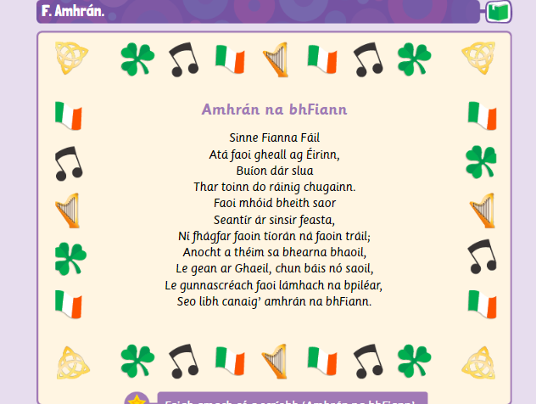
Science | Topic: Water Birds  - What are the common water birds found in Ireland? Answer orally  - Read pg. 64 + 65 in your science book.  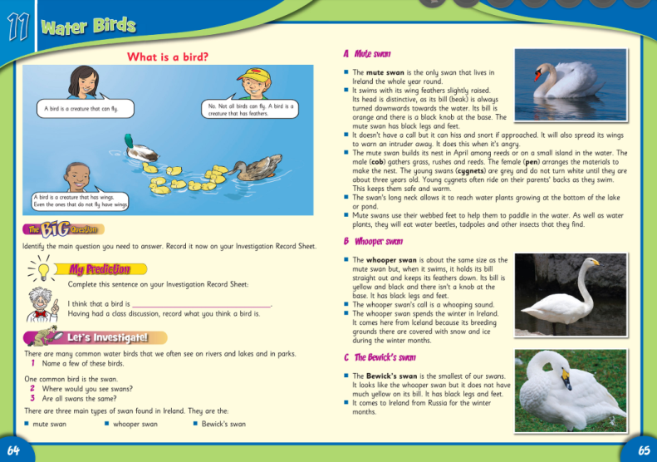  - Write at least 3 facts about each of the three main swans found in Ireland. Try and draw a simple sketch beside each type.
Music | 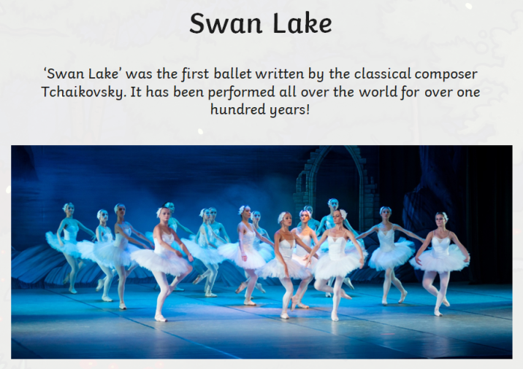  - Listen to this famous piece of music composed by classical conductor Tchaikovsky for the ‘Swan Lake’ ballet:  https://www.youtube.com/watch?v=9cNQFB0TDfY  - Have you heard this piece of music before?  - What is the mood of the piece? How does the mood change halfway through the piece?  - How does it make you feel/ what does it make you think of?  - Now listen to this second piece of music also composed by Tchaikovsky for ‘Swan Lake’  https://www.youtube.com/watch?v=EVSb3dFszH4  - How is the mood of this piece different to the first one? What other differences do you notice?  The mood of a piece of music is affected by a lot of different things.  This main three things that affect it usually are:  - The tempo (How fast/slow it is)  - The key (Major key = usually sounds happy. Minor key = usually sounds sad)  - The dynamics (How loud or quiet it is).

Wednesday
English | Reading:  - My Read at home: pg. 106 and answer questions orally  - Up and Running: wordlist “The Hat and the Superglue”  - DEAR: 10 mins  Writing:  - Up & Running: Answer the questions in Quest + Query, Ex. D pg. 202  - My Spelling Workbook: Unit 16, LSCWC x4 spellings (revision words)  - My Spelling Workbook: Exercise 8
P.E  Mindfulness | Make up your own workout or dance to your favourite song!  Read page 15 of your wellbeing pack and complete the activities.  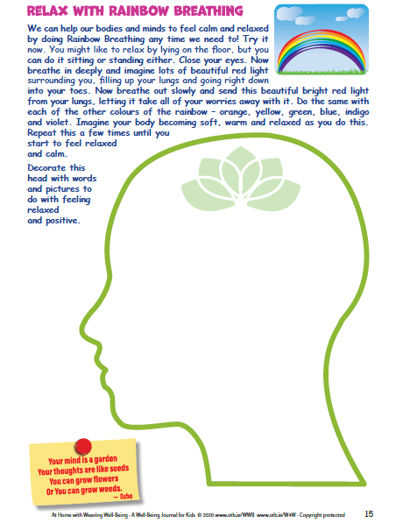
Maths | Planet Maths: Pg. 139  Topic: The Circle  - Sing your multiplication counting songs  - Complete exercise A (4) pg. 139 in your copy.  - Read the blue box: Constructing a circle 2 on page 139.  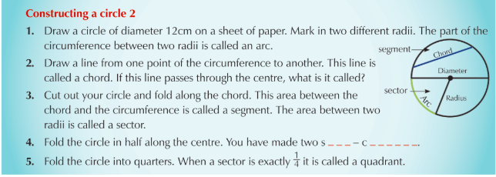  - Follow the steps in the blue box to draw the circle and label all the parts (chord, diameter, radius etc.) Try and learn the meaning of these new terms. Answer the questions in the blue box orally.  - Now draw a circle of radius 4cm and label all of the different parts again.  - Tables Champion: Wednesday  - Mental Maths: Wednesday
Religion | - To learn: For memorisation  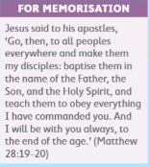
Gaeilge | - Léigh an cómhrá arís (Practise reading the cómhrá)  - Déan cleachtadh ar Amhrán na bhFiann (Practise singing Amhrán na bhFiann)  - Scríobh trí abairtí ag úsaid na focail agus frásaí nua ar lch 124 (Write 3 sentences using the new vocabulary and phrases on page 124
History | Topic: Martin Luther King  - Read pages 95 + 96 of your book about Martin Luther King’s famous speech “I have a Dream” and his assassination.  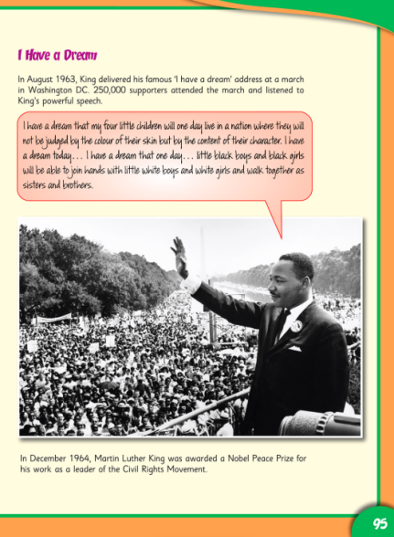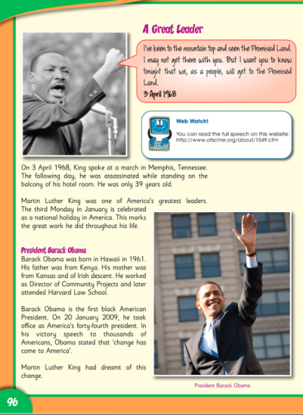  - Watch a short clip of him giving this speech in Washington D.C in 1963: https://www.youtube.com/watch?v=fR-PReWhMGM  - Using the worksheet, or your copy, write about your dreams and hopes to make our future world a better place. (You can find it on class webpage)  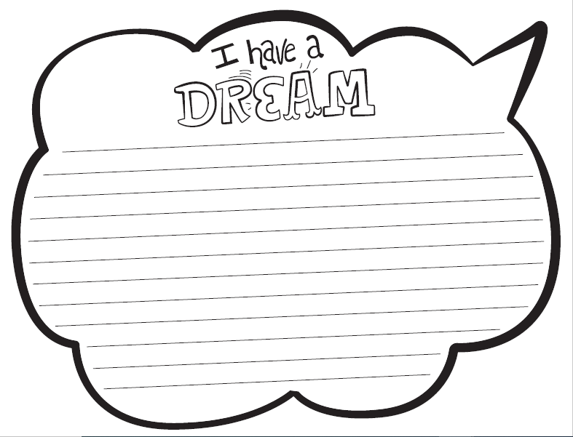  - Answer the questions on page 97 orally.

Thursday
English | Reading:  - My Read at home: pg. 107  - Up and Running: wordlist “The Hat and the Superglue”  - Look at the Power Point on Persuasive Writing in Advertisements. (It can be found on our class page on the website)  - Use the Persuasive Hotel Advertisement example as a guide to structure your writing. (It can be found on our class web page)  - DEAR: 10 mins  Writing:  - Persuasive Advertisement: Write a persuasive advertisement or brochure for a holiday destination/resort/accommodation. I have given you details and some ideas at the end of the power point! (This poster is available to view on our class page and it is in the PowerPoint)  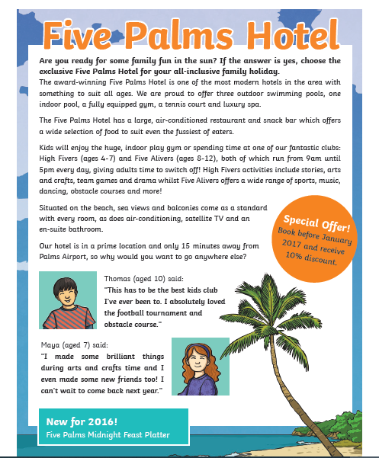  - My Spelling Workbook: Exercise 9.
P.E  Mindfulness | Complete one of the P.E with Joe (‘The Body Coach’) videos.  https://www.youtube.com/playlist?list=PLyCLoPd4VxBsXs1WmPcektsQyFbXTf9FO  Read page 16 of your wellbeing work pack and complete the activity.  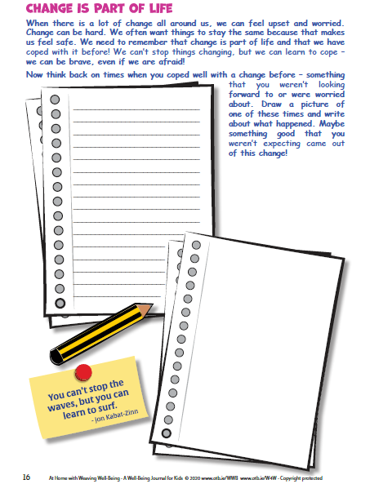
Maths | Planet Maths: Pg. 140  Topic: The Circle  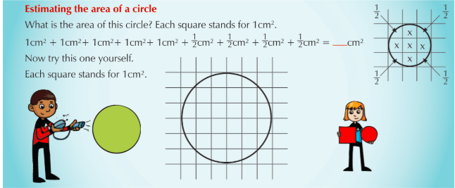  - Read the blue box about how to find the area of a circle.  - Answer exercises A + B pg. 140 in your copy.  - Test your knowledge and see how many parts of the circle you can label on this worksheet (on class page)  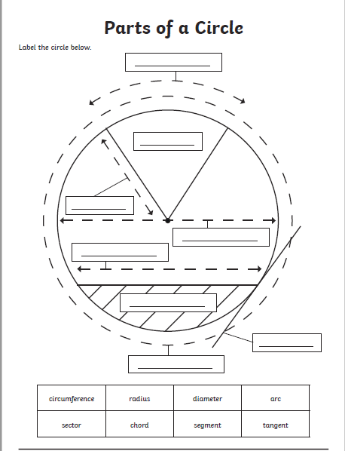  - Tables Champion: Thursday  - Mental Maths: Thursday
Religion | - Read the “At Home” page 105 with a parent or family members.  - Chat together about a special occasion that you celebrated in the church.  - Say the prayer together  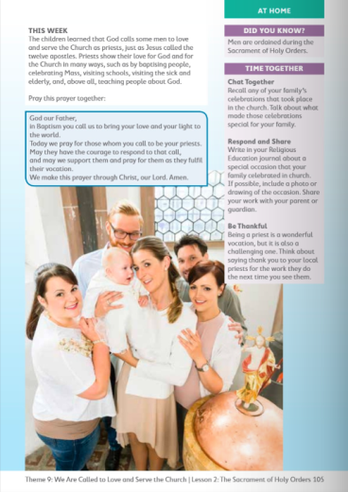
Gaeilge | Gramadach : ‘As’ lch 129  1. Déan an ceacht gramadach H (1-8) ar lch 129 i do chóipleabhar. (Write the sentences in your copy.  2. Déan cleachtadh ar ‘Amhrán na bhFiann’ (Practise singing Amhrán na bhFiann).  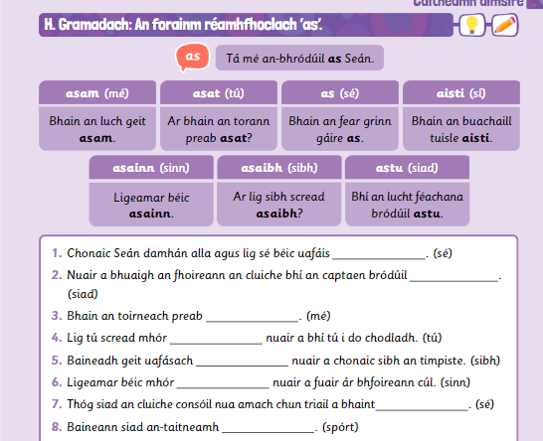
Art | Topic: Swans  Use this website to learn how to draw or sketch a swan: https://artprojectsforkids.org/how-to-draw-a-swan/  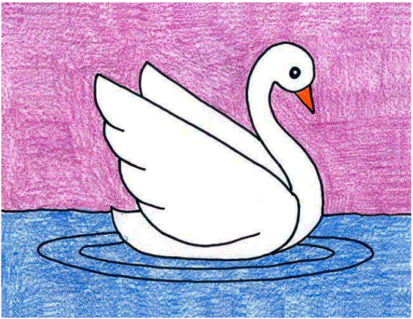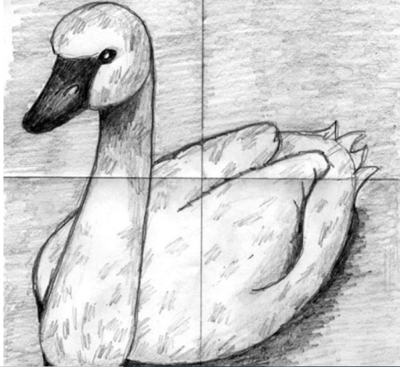  Some more ideas:  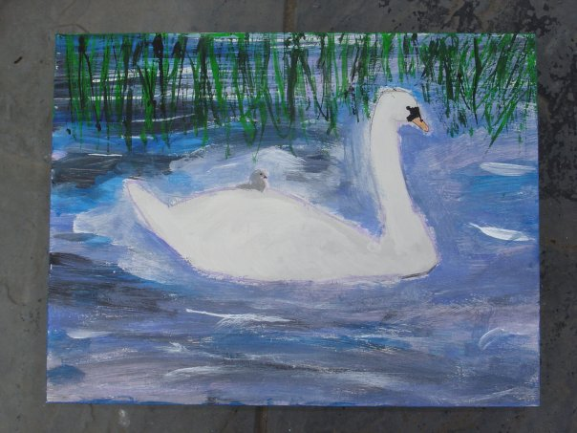  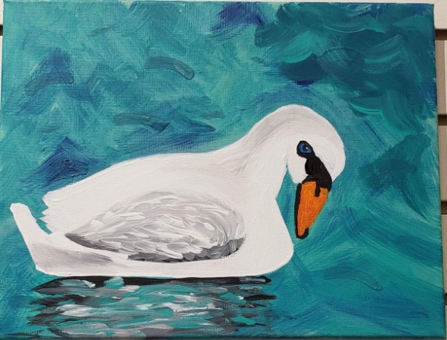  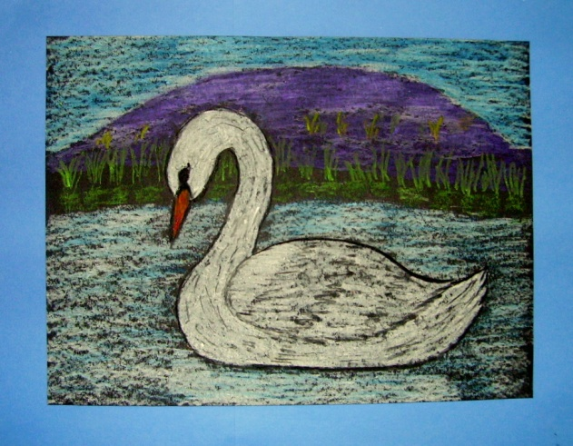
Science | - Read about common water birds found in Ireland on pages 66, 67, 68 + 69.  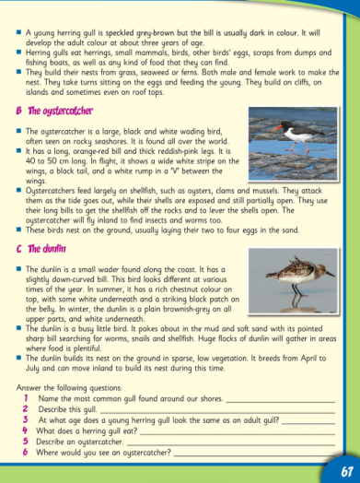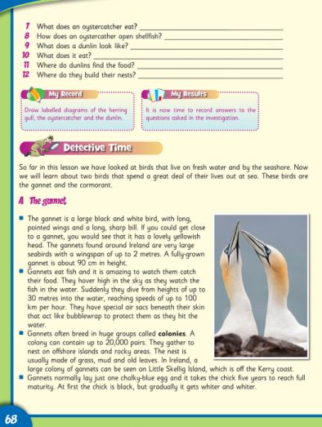  - Answer the questions on the bottom of page 67 orally.  - Chose one of the 5 birds you’ve just read about and write a fact file (information and a picture) about them. You could use this template or just any a4 sheet (available on web page)  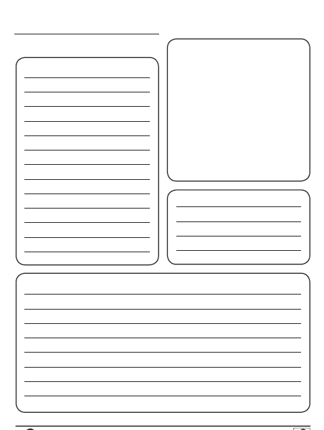  - Have a look at this website about the conservation of certain water birds around the world! https://waterbirds.org/

Friday
English | Reading:  - Up and Running: Poem: “Mr. Nobody” pg. 201  - Up and Running: wordlist “The Hat and the Superglue”  - Revise all spellings unit 16  - DEAR: 10 mins  Writing:  - Answer these 5 questions about the poem “Mr. Nobody”, in your copy:  - What is the mood of this poem?  - Are there any rhymes or patterns in the poem?  - What did you think of the poem?  - My Spelling Workbook: Exercise 10
P.E  Mindfulness | Do 15 minutes of any exercise of your choice  Complete page 17 of your wellbeing work pack. I can’t wait to see your bravery posters! Send them in and I’ll display them in a dedicated photo gallery for “Mindfulness Creativity”.  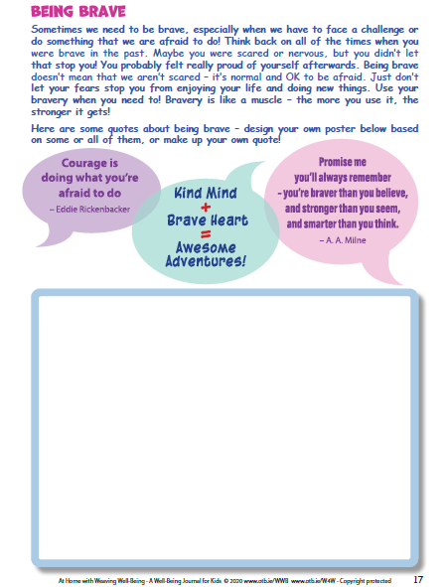
Maths | Planet Maths: Page 141  - Counting, skip counting (10 mins)  - Answer ex. A pg. 141 in your copy.  - Mental Maths: Friday Test
Gaeilge | - Léigh an cómhrá arís ar lch.126 agus na eiseamláirí agus focóir nua.  - Déan cleachtadh ar ‘Amhrán na bhFiann’  - Freagair na ceisteanna ar lch. 129 (Bródúil = Proud)  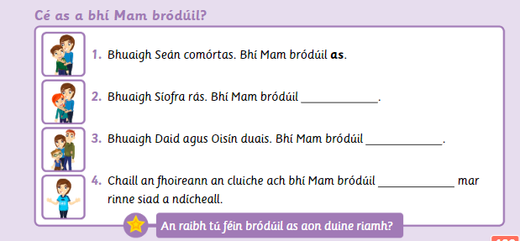
Religion | - Say the Angelus at 12:00 noon or 6:00pm  - Take 5 mins of quite time to pray or have a conversation with God.
History | Topic: Martin Luther King  - Look at the PowerPoint on Martin Luther King as a recap of the chapter.  - Complete the Martin Luther King Fact Sheet (Both on class web page)  