Active Schools week 2020:

- Go Noodle Dance: This year our dance will be “Roar“,
https://app.gonoodle.com/activities/roar?s=Search&t=KIDSBOP
- Try and practise it every day. Get all the family involved.

- Wake up Shake up: Why not try this every morning before you start your school work:
- 10 jumping jacks
- 10 frog jumps
- Run on the spot for 30 seconds
- 10 squats
- 10 lunges
- Skipping for 30 seconds
- High knees for 30 seconds
- Stretch up to the sky, to the left side and to the right side
- Stretch those legs and those arms

Monday: “Marathon Monday”
- See how many laps of your garden you can do in the day!
- Challenge other members of your family.

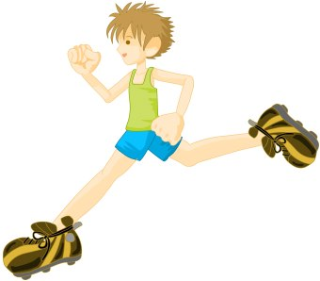

Tuesday: “Target Tuesday”
- Using whatever equipment you have, set up a target challenge for your family in the garden.
- For example: How many footballs/tennis balls/toilet rolls can you get in to the bucket?

Wednesday: “Walk On Wednesday”
- Be sure to get out for a walk with your family today.
- You could organise the pre walk warm up and cool down for the family.
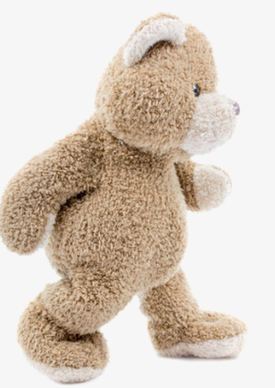
- Younger children might like to bring their favourite teddy on their walk today

Thursday: “Timing Thursday”
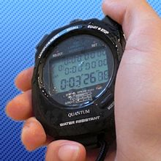
- Get the stopwatch ready: See how many of the following you can do in 1 minute?
- Jumping Jacks
- Frog Jumps
- Squats
- Lunges
- Scissors
- “Keepy uppies”
- Toe taps
- Challenge other members of your family!
Friday: “Fun Friday”
- Create an obstacle course for your family in the garden, using household and garden items (kitchen chairs, pots, laundry basket, dustbin, garden pots, buckets, a pillow case as a sack etc.)
- Who will be the fastest family member to complete it?
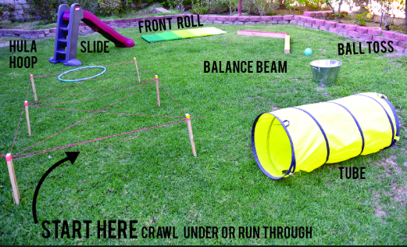
Other Activities:
- Try and join in to PE with Joe Wicks at 9.00am every morning.
- https://rtejr.rte.ie/10at10/ have loads of fun 10@10 exercises too.
- Senior kids could try them in Irish.
- Try some yoga on Cosmic kids https://www.youtube.com/user/CosmicKidsYoga
- Choose your favourite song and create your own dance to it.
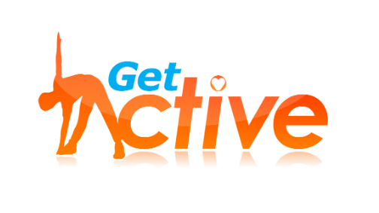
- Practise your favourite sport.

