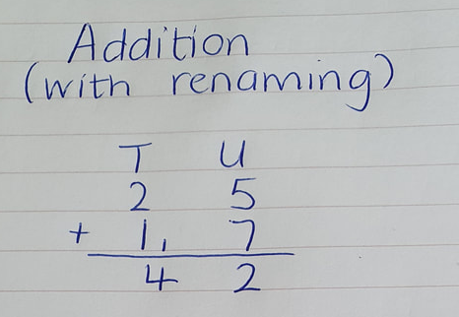
- Start with the units, 5+7=12.
We know that 12 is 1 ten and 2 units.

- Carry the ‘ten’ part of 12 up to the ‘tens’ column. Write this ten on the line. Look at my picture to help you.

- Add the tens together. Make sure you add in the ten you carried up too!

