Friday April 24th 2020
3rd Class Ms Hughes
English (My Read at Home and Get Set are available online see webpage)
- Spelling Test- do your spelling test and get someone to correct it!
- Reading Comprehension- Read the Boy Who cried Wolf text and answer the questions.
The text should be read at least 3 times.
- Read text
- Read questions
- Read text
- Answer questions
- Check questions

- Handwriting- complete pages 64+65
- My Read at home OR Library Book
Read your library book or listen to a story on www.storylineonline.net/library/ or Elevenses with David Walliams

Maths (Planet Maths available online see webpage)
- Mental Maths Book- Week 28 pg 83 complete Friday
- Tables Champion- Week 27 pg 36 complete Friday
- Warm Up: Practice x tables https://www.ictgames.com/mobilePage/numberFactBingo/
- Planet Maths- answer in Math copy if you have it or on any paper you have
Task 1-Answer pg 131 QC (1-3)
Task 2-Answer pg 131 QD (1-4)
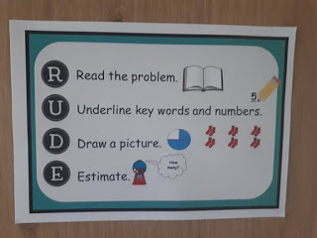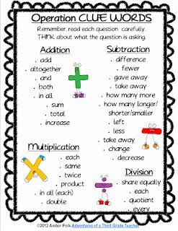
- Look for clue words when reading word problems in QC.
- Use some of the clue words when writing word problems in QD.

Remember to use the R-U-D-E Strategy when solving word problems.
Gaeilge
- Seanfhocail: Ní neart go cur le chéile (There is strength in unity)
- Téama: An Aimsir (The Weather)
- Litriú Bingo: Draw a grid with 6 boxes. Choose 6 of your litriú words this week and write one word in each box. Ask someone to call out a word from the 8 litriú words this week. Remember if you get bingo ‘Tá Bingo agam!’
Religion
- Log in to ‘Grow in Love’ https://www.growinlove.ie/en/ and access the 3rd class materials. Email: trial@growinlove.ie Password: growinlove
- Select Third Class. Click into Theme 8: The Church is a Community of Believers Lesson 1 : Pentecost
- Read page 68 and complete the activity.
Movement Well done you’ve made it to the end of the week. Click on the link below to get moving.
https://app.gonoodle.com/activities/im-still-standing?s=Search&t=im%20still%20standing
Have a great weekend!

