Friday May 1st 2020
3rd Class Ms Hughes
English (My Read at Home and Get Set are available online see webpage)
- Spelling Test- do your spelling test and get someone to correct it!
- Writing – Read and design a poster.
- Handwriting- complete pages 66+67
- My Read at home OR Library Book
Read your library book or listen to a story on www.storylineonline.net/library/ or Elevenses with David Walliams

Maths (Planet Maths available online see webpage)
- Mental Maths Book- Week 29 pg 83 complete Friday
- Tables Champion- Week 28 pg 37 complete Friday
- Warm Up: Symmetry Quiz on power point.
Watch https://youtu.be/YFzktJNmnPU again if you want to revise.
- Planet Maths-answer in Math copy if you have it or on any paper you have Topic 22: Symmetry pg 137 Check-Up!
Identify and draw lines of symmetry in 2D Shapes
Answer QA,B,C,D and E pg 137
Gaeilge
- Seanfhocail: Ní neart go cur le chéile (There is strength in unity)
- Téama: An Aimsir (The Weather)
- Litriú Bingo: Draw a grid with 6 boxes. Choose 6 of your litriú words this week and write one word in each box. Ask someone to call out a word from the 8 litriú words this week. Remember if you get bingo ‘Tá Bingo agam!’
Religion
- Log in to ‘Grow in Love’ https://www.growinlove.ie/en/ and access the 3rd class materials. Email: trial@growinlove.ie Password: growinlove
- Select Third Class. Click into Theme 8: The Church is a Community of Believers Lesson 2 : Life in the Parish
- Listen to the reflective music and say a prayer for anyone that is lonely or unwell at the moment.
Science
- What is a food chain? What is a food web?
- Find out here https://youtu.be/UXZ9oGUFje0
- Draw an example of a food chain and explain it to someone at home.
- Draw an example of a food web and explain it to someone at home.
- Read Ch 15 Window on the World Science pg 80-83 to find out more.

Movement
- Perform for an audience our dance for Active Schools Week
https://app.gonoodle.com/activities/roar?s=Search&t=roar
- Enjoy!!!! Roooooaaarrrr!!

Active Schools Week
Friday: “Fun Friday”
- Create an obstacle course for your family in the garden, using household and garden items (kitchen chairs, pots, laundry basket, dustbin, garden pots, buckets, a pillow case as a sack etc.)
- Who will be the fastest family member to complete it?
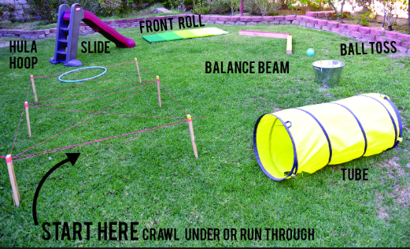

Well done for all your hard work!
Have a great weekend!

