Junior Infants daily work (25th- 29th of May)
Try your best to get through the work but don’t worry if you don’t get it all completed ☺

Monday:
Irish:
Téama: Ócáidí Specialta – Lá Breithe
Ceacht 1:
- Listen to the song “Ceithre Bliana Inniu” and make up your own actions.
- Listen to the comhrá pausing at different places and repeating what is being said.
- Play cluice meatséala
- Try the tasc éisteachta
- Bua na Cainte p 44

English:
- Wordbox 10a (1-5)
- Tricky words (1-20)
- Reading: Sentences 46 and 47: write and draw a picture of them.
- Phonics: “ee”
- Writing: How many words can you write with “ee” in them?
- Word Wizard page 66

Maths:
- Use your cubes to count 1-10 forwards and backwards.
- Our topic today is patterns. Can you see a pattern anywhere in your house/outside (tiles on the floor/ bricks on the wall/ a fence/ plants etc.)
- Have you an item of clothing that has a pattern? (scarf/socks etc.)
- Try this pattern making game from the planet maths website: https://content.folensonline.ie/programmes/PlanetMaths/PMJI/resources/activities/pm_ji_050/index.html
- Planet math’s page 50

Religion:
Theme 8: Water
Lesson 2: Welcomed with Water
- Watch the video on Holy water.
- Chat about it afterwards (have you ever seen anyone use holy water? Where do they keep it? Who or what would you like to bless with holy water?)

SESE:
- Listen to the story The Salmon of Knowledge: https://www.youtube.com/watch?v=e9LKEBq5-Iw
- I have attached sequencing cards on our website page to help retell the story in order. You can cut these out and see if you can get them in the right order.
- Identify 3 key moments in the story to represent the beginning, middle and end of the story and draw pictures for each moment.
- Optional: I have also attached some Salmon of Knowledge colouring pages if they would like to do any of them.

Tuesday:

Irish:
Ceacht 2:
- Listen to the song “Lá Breithe Sona Duit” and make up your own actions.
- Listen to the comhrá pausing at different places and repeating what is being said.
- Play cluiche Kim and cluiche cuimhne
- Tasc éisteachta
- Draw a picture of the presents you might like for your next birthday (carr, rothar, bábog, liathróid, eitléan, bád, leabhar) Can you say what they are in Irish after?

English:
- Wordbox 10a (1-5)
- Tricky words (1-20)
- Reading: Sentences 48, 49 and 50: write and draw a picture of them.
- Phonics: “or”
- Writing: Practise writing words that have “or” in them.
- Word Wizard page 68

Maths:
- Counting song
- Using your cubes make a set of 0/1/2/3/4/5/6/7/8/9/10
- Watch this video on people patterns: https://content.folensonline.ie/programmes/PlanetMaths/PMJI/resources/video/pm_ji_v050.mp4
- Could you do one like it with your teddies or members of your family?
- Planet Maths page 51

Religion:
- Read the below story Welcomed with Water to the children. There are accompanying pictures on the Grow in Love website.
- Ask them questions afterwards (Have you ever been to a baptism? What different things did Niamh see when she was in the church? What words did Fr José say when he poured the water over Lucy’s head etc.)
- Grow in Love workbook page 48

PE:
- Be sure to try and do your PE lesson with Joe Wicks this morning.
- You could try this fishy dance from Go Noodle: https://app.gonoodle.com/activities/poppin-bubbles?s=category&t=Guided%20Dance&sid=38

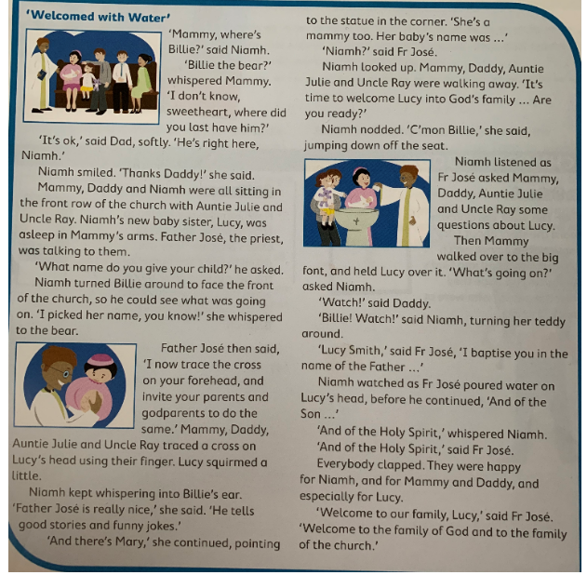

Wednesday:

Irish:
Ceacht 3:
- Listen to the rann “Rinne Oisín Cáca” and make up your own actions.
- Listen to the comhrá pausing at different places and repeating what is being said.
- Try acting out the comhrá with your own teddy.
- Play cluiche Kim and cluiche cuimhne.
- Try the tasc éisteachta
- Draw a picture of a cáca you would like for your next birthday.

English:
- Wordbox 10a (1-10)
- Tricky words (1-20)
- Reading: New sentences 1 and 2: Write and draw a picture of them.
- Phonics: “z”
- Odd one out game
- Writing: Practice writing the letter “z” (Ready to Write page 63)
- Can you write the sentence “It is a big zip.” by yourself? (Remember two finger spaces between words, froggy grip, capital letters and a full stop).

Maths:
- Counting games
- Questions on the seasons (which season comes before Spring, after Summer etc.)
- Play this pattern game: https://content.folensonline.ie/programmes/PlanetMaths/PMJI/resources/activities/pm_ji_051/index.html
- Today I would like you to create your own patterns, using counting materials/anything you have. Be sure to send me a picture of your completed patterns.

Religion:
- Look at the video on baptism.
- Chat about your own baptism: who was there? Who are your Godparents? Did the priest put holy water on your forhead?
- Grow in Love Workbook page 49

Aistear: At the Airport
I have attached some different at the airport role play scenario cards on the website page that you might like to try out today.

Water Play: Provide a water table or large, shallow, plastic boxes of water or a basin. You could add either green or blue food dye to create an ocean life scene.
- You could use shells, toy sea creatures, rocks, pebbles, sand, seaweed (use strands of green cellophane) and boats if you had them.
- The children could make boats using a range of materials – margarine tubs, foil trays, etc.
- The children can explore if their boats float or sink.

Thursday:

Irish:
Scéal: An Féasta
- Listen to all the songs and poem from this theme.
- Listen to the story An An Féasta.
- Play the story again, pausing at different parts and try repeating the lines.
- Draw a picture of the story.

English:
- Wordbox 10a (1-10)
- Tricky words (1-20)
- Reading: Sentences 3 and 4: write and draw a picture of them.
- Phonics: “w”
- Writing: Practice writing the letter “w” (Ready to Write page 61)
- How many words can you make beginning with “w” using your letters on card?

Maths:
- Counting song
- Pattern game: https://content.folensonline.ie/programmes/PlanetMaths/PMJI/resources/activities/pm_ji_050a/index.html
- Today I would like you to draw your own patterns, be as creative as you like.

Religion:
- Look at poster 10 and chat about what is happening.
- Draw a picture of all the people or things you would like to bless with holy water.
- If you happen to have holy water at home you could use it to bless yourself and others or even your teddies.

Art: Celery Printing Rainbow fish
- Listen to the story of the Rainbow Fish: https://www.youtube.com/watch?v=r9mryuEKkKc
- I have attached a letter from the rainbow fish to the children asking for his scales back and a rainbow fish template if you would like to use it.
- Cut up one stick of celery into 6 pieces. Put out rainbow coloured paints and have the children dip each one.
- Starting from the front of the fish, stamp the celery to make it look like fish scales.
- Paint the fins and tail.
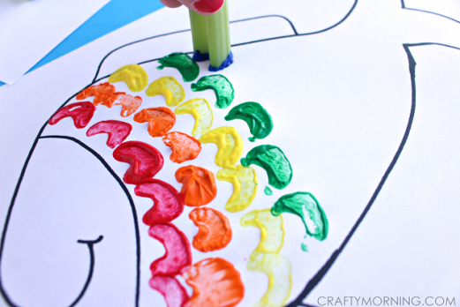

Friday:

Irish:
- Listen to all the songs and poem from this theme.
- Practise the lines from ceacht 1: Cén aois tú? Tá mé ______ bliana d’aois (trí, ceithre, cúig, sé). Ask the question to different members of your family and get them to ask you.
- Create a lá breithe for one of your teddys/dolls/action figures. How many Irish words can you use at the party?

English:
- Wordbox 10a (1-10)
- Tricky words (1-20)
- Reading: Sentences 5 and 6: write and draw a picture of them.
- Phonics: “ng”
- How many words rhyming with sing can you think of?
- Writing: Practice writing words with “ng” in them.
- Word Wizard page 71: sight words revision game

Maths:
- Counting games
- Days of the week: Today is _______. Here is a lovely sing along video for the days of the week: https://www.youtube.com/watch?v=spi77By9-iA
- Try this game: https://content.folensonline.ie/programmes/PlanetMaths/PMJI/resources/activities/pm_ji_097/index.html
- With your cubes I would like you to build towers of different heights (a tower of 3 cubes/6 cubes/9 cubes etc.)
- Planet Maths page 96

Religion/SPHE:
- Today I would like you to think of 5 different people you would like to thank and why.
- Put on the reflective music on the Grow in Love website and say a little prayer for them.

PE:
- Try this fishy Cosmic kids yoga: https://www.youtube.com/watch?v=LhYtcadR9nw

- Be sure to do your PE with Joe Wicks today.

Well done on working so hard this week.
Have a lovely weekend and enjoy a well deserved rest!!

Ms O’ Grady

