Happy Monday 18th May! : )
English
1. Write your news from the weekend and draw a picture.
2. Read P. 60 and answer the questions orally
3. Spelling Workbook: Unit 7– exercise 9 and 10
4. Spelling list 27: put one word from the spelling list into a sentence

Maths
- Mental Maths: Week 31 Monday and the problem
- Tables: -8
- Planet Maths: p153 (attached below)
Gaeilge: Bua naCainte –Siopadóireacht- Ceacht 1
- Click the green musical note and listen to the song
- Click the Yellow speech bubble and listen to comhra 1.1
- Read Bua na Cainte p.76
Religion Theme 9: Lesson 2 - Sign up to ‘Grow in Love’ and access the 1st class materials. (Email address: trial@growinlove.ie Password: growinlove)
- Watch the video ‘Creation part 3’
- Complete page 52 by asking the questions to someone in your house.
P.E Take part in 30 minutes of exercise; play in the garden, go for a walk or take part in one of Joe Wick’s PE lessons on YouTube.
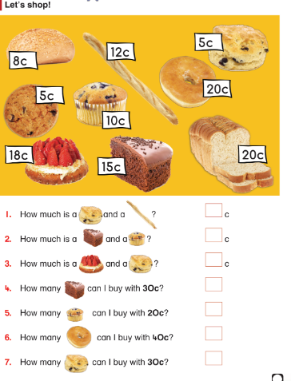

Tuesday 19th May
English
- Read the poem ‘Who’s there?’ p. 64
- Do you think a dinosaur be a good pet? Write as many reasons as you can for this.
Example 1: I think a dinosaur would be a good pet because it would scare away any robbers from my house.
Example 2: I do not think a dinosaur would be a good pet because it would be too big for my house.
Draw a picture to go with your sentences.
- Spelling Workbook: Unit 7 exercise 11
- Spelling list 27: Put one word from today’s spellings into a sentence.
Maths
- Mental Maths: Week 31 Tuesday and the problem
- Tables: -8
- Planet Maths: p154 (Attached below)
Gaeilge: Siopadoireacht-ceacht 1
- Click the yellow bubble and listen to comhra 1.2
- Click the game icon and play the ‘Bí ag scriobh’ game
Religion: Theme 9 Lesson 2
- Watch the videos: ‘Thank you lord for making me’ and ‘ Taking care of our world’
- Complete p.53 in G.I.L workbook.
SESE: Wildflowers
- Use the PowerPoint on wildflowers to help explain what wildflowers are.
- My favourite wildflower is a daisy, I like to make daisy chains when I am sitting on the grass. What is you favourite wildflower? Take a wildflower hunt in your garden to see. Can you find a primrose(Buttercup), dandelion and a daisy? What other wildflowers did you find?
- Complete the following worksheet. This can be printed out or the sentences can be written into a copy or completed orally.
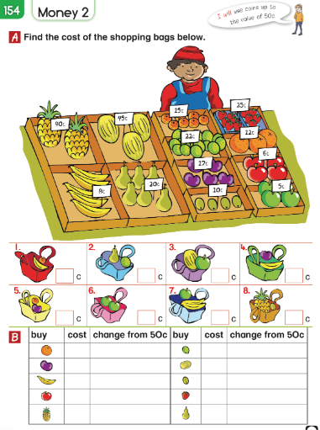

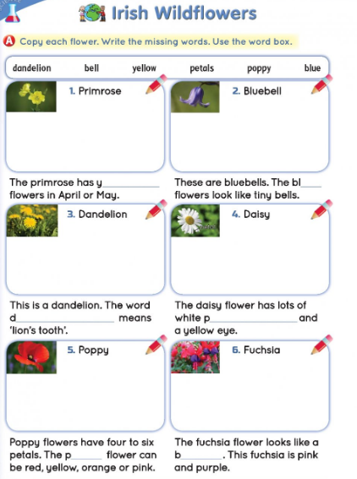

Well done for all your hard work today!
Wednesday 20th May

English
- Spelling workbook: Unit 9 exercise 12
- Spelling list 27: Put one word from today’s spellings into a sentence.
- A or an: Can you remember the vowels? When a word starts with a vowel (a, e, i, o and u) we put ‘an’ in front of it. For example, an umbrella. Complete the following worksheet by putting ‘an’ or ‘a’ before the words. It can be printed out or the sentences can be written out in a copy.

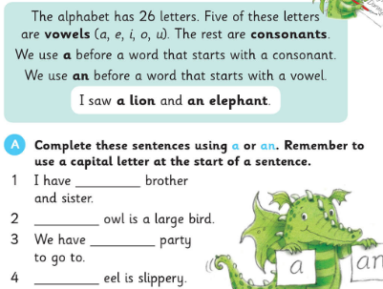
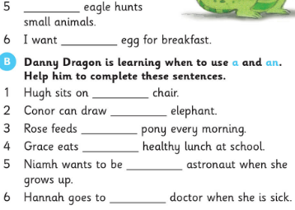

Well-Being
- Read ‘Everybody Worries’. This is available on the class page.
- It is very important that we look after ourselves. I know things might seem a bit strange at the moment. Sometimes you might even feel a bit scared. When I feel scared or I am worrying about something I like to remember some happy times I have had. This also reminds me how lucky I am.
These happy memories could be a birthday party, playing a match, playing with my friends, going shopping with my Mammy, having dinner in my Nanny’s house. Complete the following worksheet. No need to print this sheet out, just draw 4 happy memories on a blank page. If you can, write a sentence to go with them.

- 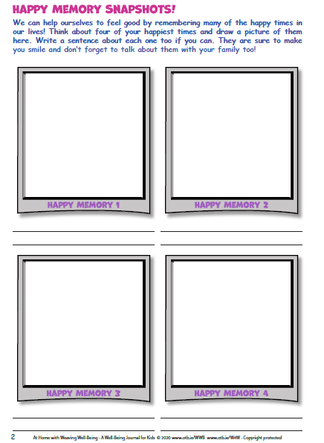
Maths
- Mental Maths: Week 31 Wednesday and the problem
- Tables: -8
- Show me the coins I have in my purse. No need to print this sheet out, just draw circles as the purse and draw the coins in it. You can use real coins if you have some!

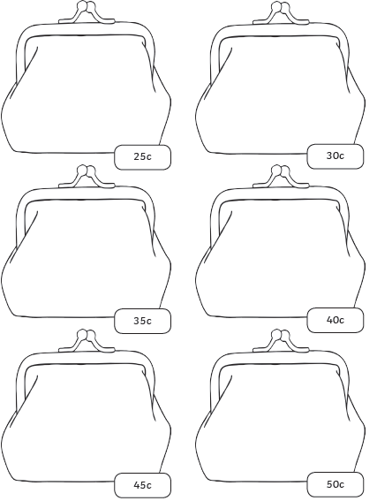

This sheet can be done orally. Calculate the change you will get if you but these items in the shop. If it is possible, play shop using real coins with someone at home.
- 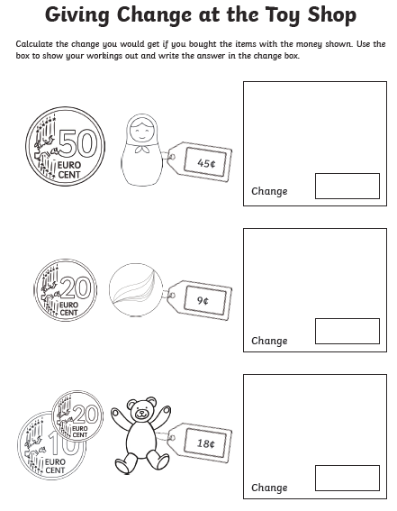

Gaeilge: Siopadoireacht- Ceacht 1
- Click the yellow speech bubble and listen to comhra 1.2
- Complete Bua na cainte p.77
Art: Try to draw this turtle!
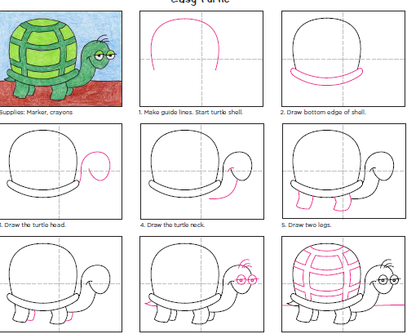
Thursday 21st May
English
- Spelling list 27: Put one word from today’s spelling list into a sentence.
- Spelling workbook: Unit 7 exercise 12
- Read the following and answer the questions.
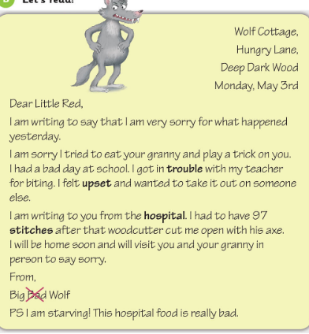
Remember to use full sentences when answering these questions and every sentence must start with a capital letter.
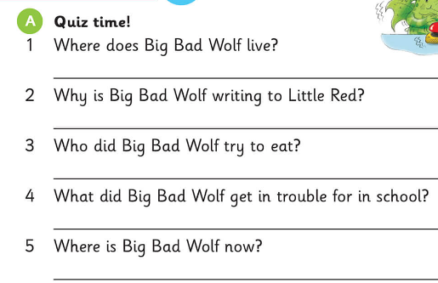

Maths
- Mental Maths: Week 31 Thursday and the problem.
- Tables: -8
- Complete the following worksheets.
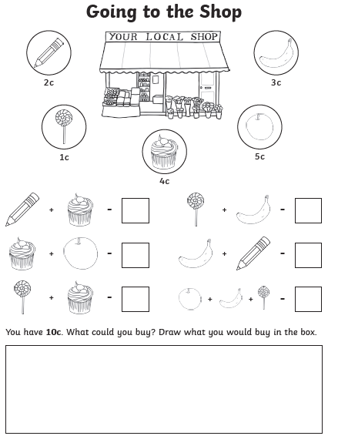
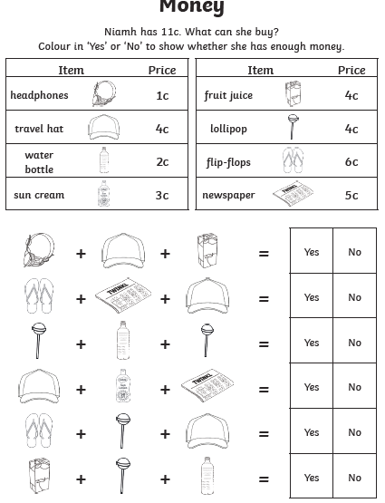
Gaeilge: Ceacht 3
- Click the music note and listen to the song for this lesson
- Click the yellow speech bubble and listen to comhra 1.1 ‘Cé a cheannaigh...?’ (Who bought...?) Cheannaigh mé... (I bought...)
- On a blank page draw a shopping bag and put 3 items it in. Write the sentence ‘Chuaigh me go dtí an siopa agus cheannaigh mé....’ ( I went to the shop and I bought...) Use the vocabulary on p.77 and 78 to help you.

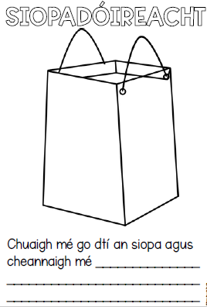
SESE: Signs of Summer
Summer is here. May is the first month of summer. What some signs of summer you might have noticed in the last few weeks? What has the weather been like? What type of clothes are you wearing? Complete the sentences below. The sheet can be printed out or the 5 sentences and picture can be written into a copy.
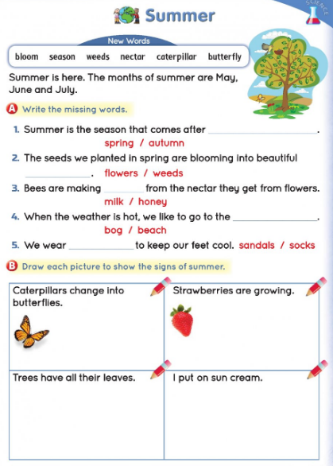

Well done today! That’s Thursday’s work done which means tomorrow is Friday!

Friday 22nd May
Happy Friday!
English:
- Spelling workbook: Unit7 exercise 13
- Spelling test: spelling list 27
Maths
- Mental Maths: Friday Review
- Table test
17-8= 13-8= 11-8=
9-8= 10-8= 15-8=
8-5= 12-8= 16-8=
14-8= 8-8= 18-8=
Gaeilge: Ceacht 3
- Click the yellow speech bubble and listen to comhra 3.2
- Complete Bua na Cainte p. 77
PE: Complete 30 minutes of exercise.
Well done on all your hard work this week.

