Wednesday 6th May
Happy Wednesday! I hope you enjoyed the Bank Holiday weekend : )
English
1. Write your news from the long weekend and draw a picture.
2. Read P. 42 and 43 of the story ‘Sleep tight’.
3. Spelling Workbook: Unit 6 – exercise 8
4. Spelling list 25: put one word from the spelling list into a sentence

Maths
- Mental Maths: Week 29 Monday and Tuesday p. 58 and the problems
- Tables: -6
- Planet Maths p. 142
Gaeilge
- Bua na Cainte Workbook: Read the story on p.71
- Colour the picture
Religion Theme 8: Lesson 3
- Watch the video ‘The Holy Spirit helps Jesus and his friends’ and talk about it with your family.4
- G.I.L workbook p. 48

Art:
As today is Wednesday, we would usually be doing Art. Below I have attached a sample if you want to give it a go! The faded blue lines show where you should fold your page in 4…this will help you layout the picture as they have done. All you need is an A4 piece of paper, a pencil and some colours!
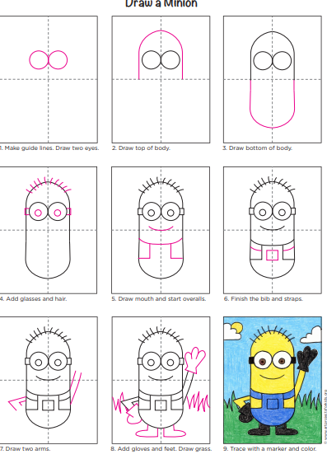

Thursday 7th May
English
- Read the story ‘Sleep tight’ P.44 and 45
- Spelling Workbook: Unit 6 exercise 9
- Spelling list 25: Put one word from today’s spellings into a sentence.
- Skills book: Complete the following sentences (on next page) by using either ‘Could’ or ‘could not’.
Write 2 of your own sentences using either ‘Could’ or ‘could not’. This can be printed out or sentences written into a copy.

- Grammar: Can you remember what a compound word is? A compound word it when two small words come together to make a new word.
Can you make new words orally using the pictures below? No need to print or draw these pictures out!

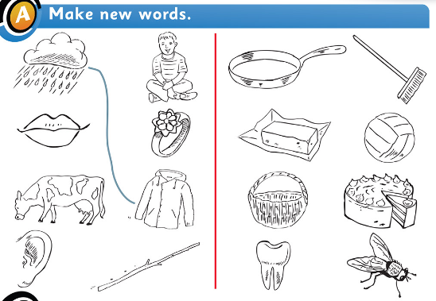
Orally, make compound words using the images below.
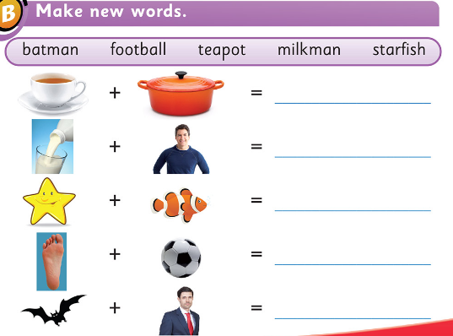

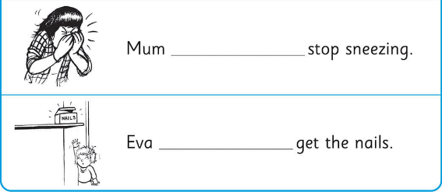
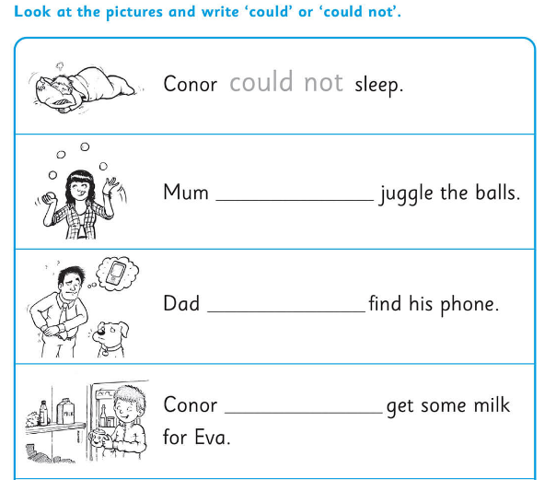
Maths
- Mental Maths: Week 29 Wednesday and the problem
- Tables: -6
- Complete the sums below. Remember to show the ‘ten’ being carried up.

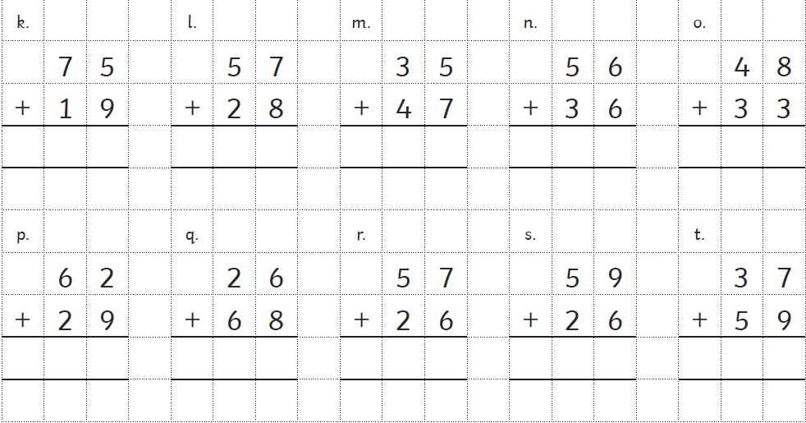

Gaeilge: Teílifís Cleacht 7
- An Teilifís Ceacht 7: Click on the yellow speech bubble and listen to the lesson.
- Click on the game controller and play ‘Feicim le mo Shúilín’ (Eye Spy)
- Bua na Cainte Workbook: p72
Religion: Theme 8 Lesson 3
- Watch the video ‘After Pentecost’ and talk about it with your family
- G.I.L workbook p.49
Well done for all your hard work today!

Friday 8th May

English
- Read ‘Sleep tight’ p.46,47,48
- Spelling workbook: Unit 6 exercise 10
- Spelling list 25: Test
- Skills Book: Complete the page from the skills book below. This can be printed out or written into a copy.

PE: Complete 30 minutes of exercise.

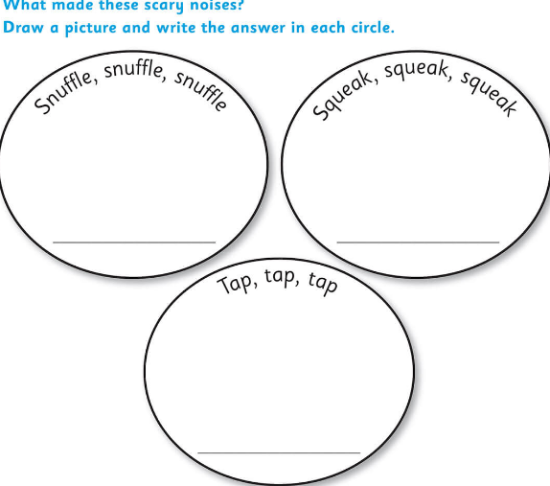
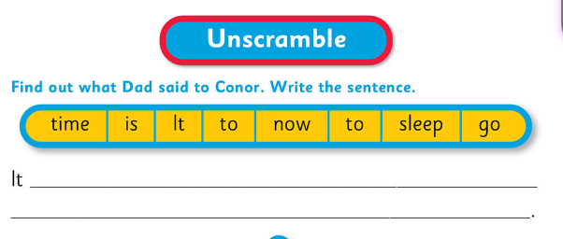
Maths
- Mental Maths: Week 29 Thursday and Friday Review
- Table Test:
17-6= 6-6= 13-6=
9-6= 10-6= 15-6=
7-6= 12-6= 16-6=
14-6= 8-6=
5-6= 11-6=

Gaeilge: Cleacht 7- comhra 5.1
- Click the yellow speech bubble and listen to the lesson again.
- Click the game controller and play ‘Faigh an focal’
- Bua na Cainte Workbook: p73
SESE: History of Egypt
- Read the page on ‘Egyptian Hieroglyphics’ and answer these questions orally or into a copy.
- What did Egyptians use for paper?
- How did Egyptians make their paper?
- Would you like to have to do your homework using Hieroglyphics? Why/Why not?

- Write your name in Hieroglyphics using the hieroglyphic alphabet. Why not try to write a secret message for someone at home to try to crack? Or send it to me to figure out!
- Look at the world map. Can you find Egypt on it? Where is Ireland?
- Complete the word search on the class page on the website.
Well done on all your hard work this week!
Have a lovely weekend!

