Thursday May 8th 2020
3rd Class Ms Hughes
English (My Read at Home and Get Set are available online see webpage)
- My Spelling Workbook pg 58 Unit 15
Today’s spellings: except-fault (LCWC) Write spelling 3 times.
Write 4 sentences with each spelling word.
Answer Q3 Across Clues pg 59 My Spelling Workbook
- Poetry- Read the poem The Dinosaur’s Dinner pg 194-195 Get Set and complete the Poem Review worksheet.
- My Read at home- Read the next page and answer questions orally.
- Library Book- Read your library book or listen to a story on www.storylineonline.net/library/ or Elevenses with David Walliams

Maths (Planet Maths available online see webpage)
- Mental Maths Book- Week 30 pg 84 complete Tuesday
- Tables Champion- Week 29 pg 38 complete Tuesday
- Warm Up-Word Problem
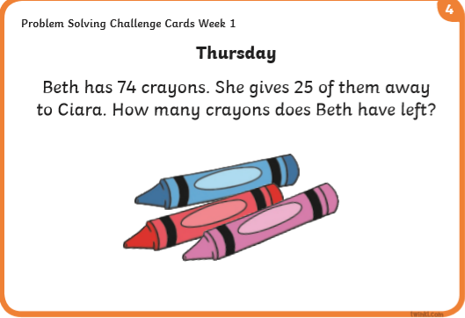

- Counting in 2, 5, 10../Singing Table songs/Making up word problems/Choose an area warm-up on padlet https://padlet.com/thirdclassmshughes/7nelhuv6lglw4ti6
What is area? Explain in your own words what area is.
What are the 2 ways to calculate area? https://youtu.be/_uKKl8R1xBM
- Planet Maths- Topic 23:Area pg 140
Estimate, compare and measure the area of regular and irregular shapes
Answer QA+B pg 140

Gaeilge
- Seanfhocail: Ní neart go cur le chéile (There is strength in unity)
- Téama: An Aimsir (The Weather) Continued
- Litriú: An Fómhar (Autumn) + An Geimhreadh (Winter). Write 3 times in copy like spellings.
- Log into Folens online and find Comhrá 16. Éist agus léigh.

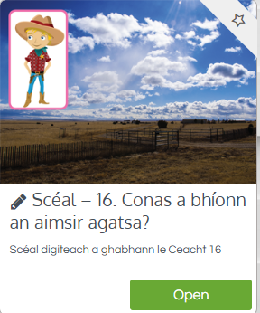
- Try and read or follow the same scéal on lch 130
- Déan iarracht (try) and answer ceist A nó (or) B ar lch 131
Religion
- Log in to ‘Grow in Love’ https://www.growinlove.ie/en/ and access the 3rd class materials. Email: trial@growinlove.ie Password: growinlove
- Select Third Class. Click into Theme 8: The Church is a Community of Believers Lesson 3: Baptism
- Watch and discuss the video Kieran remembers his Baptism
PE
- Tuesday is normally our PE day. Try it with Joe!
https://youtu.be/evqn3sgS1lU

