Tuesday June 9th 2020
3rd Class Ms Hughes
For additional support see https://padlet.com/thirdclassmshughes/7nelhuv6lglw4ti6
English (My Read at Home and Get Set are available online see webpage)
- My Spelling Workbook pg 66 Unit 17
Today’s spellings: oar-pour(LCWC) Write spelling 3 times.
Write 4 sentences with each spelling word.
Answer Q5 a-f Homonyms pg 68 My Spelling Workbook
Answer Q6 Proofreading pg 68 My Spelling Workbook
- Work on Intercultural project if not yet completed
- My Read at home- Read the next page & answer questions orally.
- Library Book- Read your library book or listen to a story on www.storylineonline.net/library/ or Elevenses with David Walliams
Maths (Planet Maths available online see webpage)
- Mental Maths Book- Week 35 pg 89 complete Tuesday
- Warm Up- Word Problem
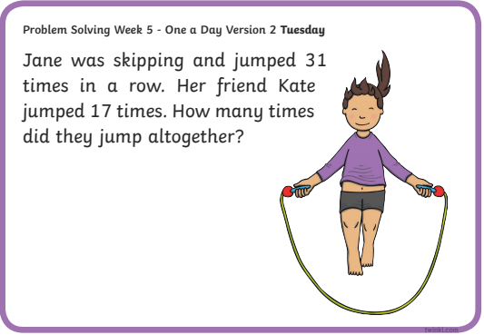
- Planet Maths- Topic 27: Time 2 pg 163
Rename minutes as hours and hours as minutes
- Watch
- Answer QA, B and C pg 163 write down answers
- Answer QD and E pg 163 Orally
Gaeilge
- Téama: Caitheamh Aimsire (Past Times)
- Abair Liom lch 159 B Comhrá
- Go on to folens online and select Comhrá https://content.folensonline.ie/programmes/AbairLiom/3rd_class/resources/Dialogue/AL_3C_ACT_DIA_CH19_008/index.html
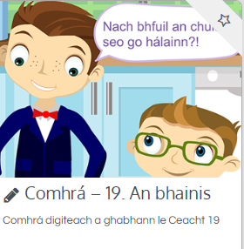
- Éist leis an comhrá. Éist a second time and follow along in your book.
- Read the comhrá out loud, get someone to join in and read a different part if you can.
- Freagair Ceist C1-5 Nach bhfuil…? Isn’t….?

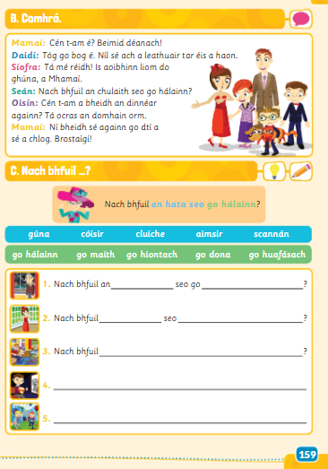

Religion
- Log in to ‘Grow in Love’ https://www.growinlove.ie/en/ and access the 3rd class materials.
- Email: trial@growinlove.ie Password: growinlove
- Select Third Class. Click into Seasonal/Additional Lesson 5: How We Have Grown in Love
- Listen to the song Bible Rap
- Read page 99 of your book and chat about it.
PE
- Tuesday is normally our PE day. Do this work out with Joe Wicks instead https://youtu.be/wpW2Mdyg-mI
- Choose an activity you haven’t done in the PE or Well-being column on padlet.

Intercultural Project
- Work on country project if not yet completed.

