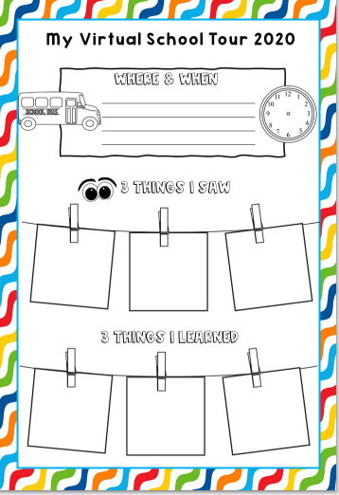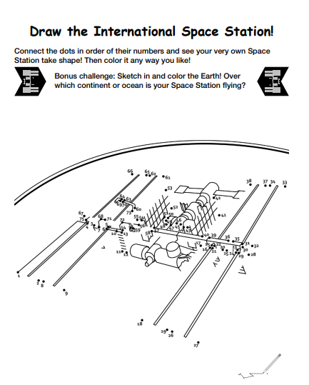

https://www.nasa.gov/sites/default/files/atoms/files/iss_activity_book.pdf
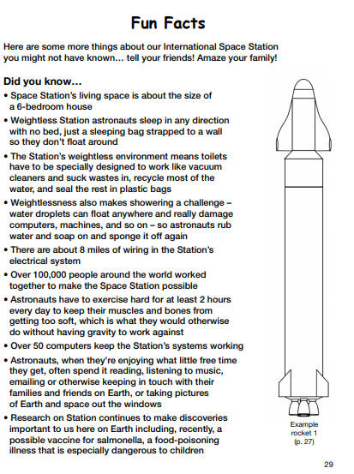
https://www.nasa.gov/sites/default/files/atoms/files/iss_activity_book.pdf
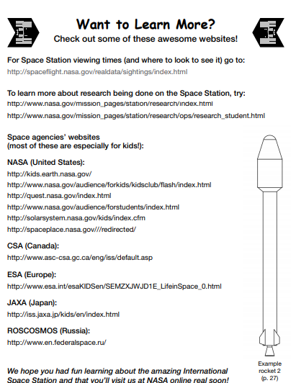

https://www.nasa.gov/sites/default/files/atoms/files/iss_activity_book.pdf

