Wednesday June 17th 2020
3rd Class Ms Hughes
For additional support see https://padlet.com/thirdclassmshughes/7nelhuv6lglw4ti6
English (My Read at Home and Get Set are available online see webpage)
- My Spelling Workbook pg 70 Unit 18
Today’s spellings: salad-caravan (LCWC) Write spelling 3 times.
Write 4 sentences with each spelling word.
Answer Q3 Crossword Down Clues pg 71 My Spelling Workbook
- My Read at home- Read the next page & answer questions orally.
- Library Book- Read your library book or listen to a story on www.storylineonline.net/library/ or Elevenses with David Walliams
Maths (Planet Maths available online see webpage)
- Mental Maths Book- Week 36 pg 107-109 complete Wednesday
Complete Wednesday for the next week that you are on. Some people are on different weeks.
- Warm Up- Word Problem
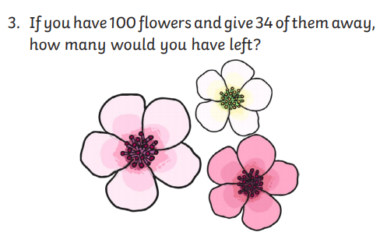

Planet Maths- Revision pg 167 Problem solving
- Access folens online and do the problem solving activity
https://content.folensonline.ie/programmes/PlanetMaths/PM3/resources/activities/pm_3c_073/index.html

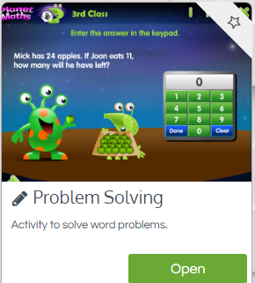
- Answer QC 1-5 pg 167
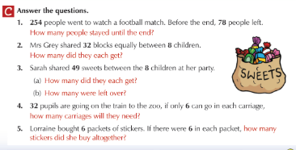

Gaeilge
- Téama: Ócáidí Speisialta (Special Occasions)
- Déan 10 as 10 https://rtejr.rte.ie/10at10/ as gaeilge
- Look at the Ceisteanna ar lch 165 Abair Liom
- Go to padlet and listen to translation
- Answer ceisteanna 1-6 lch 165

Science
- How to grow a rainbow experiment
- Watch the video https://youtu.be/8iZCNnYewmk
- Try it for yourself!
- Record what you did on the template.

Optional Choiceboard
- Choose a different activity to do each day.

